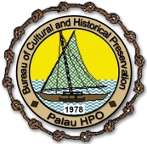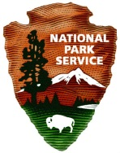
National Park Service
Bureau of Cultural & Historical Preservation

URGENT REQUEST FOR QUALIFIED INDIVIDUALS AND/OR CONTRACTORS

- Thirty (30) Days Public Notice –

RFP No. HPF 2017-001

Public Announcement: March 13 – 31, 2017 Bidding Period: April 03 – 21, 2017
The Republic of Palau’s Bureau of Cultural and Historical Preservation with grant fund through the US National Park Service, Department of the Interior is urgently seeking qualified individuals and/or contractors to conduct a: 1. Archaeological Interior Survey of Airai State under HPF Grant No. P15AF00022 and 2) Archaeological Interior Survey for Aimeliik State under HPF Grant No. P15AF00111. This project is fully funded by the U.S. Historic Preservation Grant Fund through the National Park Service, DOI. For Detail Scope of Work, please pick up a copy at the Ministry of Community and Cultural Affairs office at Ngerulmud, Executive Branch Building or email Deputy Historic Preservation Officer Calvin T. Emesiochel at bac_reg@palaunet.com, bac_arch@palaunet.com, and bac_adm@palaunet.com to obtain an electronic copy. For any other questions or comments, please contact the Bureau at +680-767-1126. Interested individuals and/or contractors can apply for both projects. Kom Kmal Mesulang (Thank you).

